**THERMOS OR VACUUM FLASK**

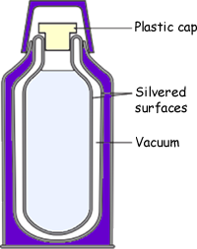

**SOLAR HOT WATER SYSEM**

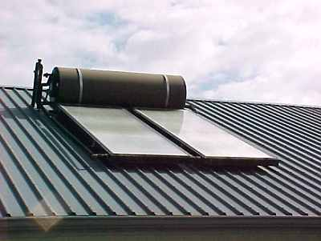

**HOME HEATING**

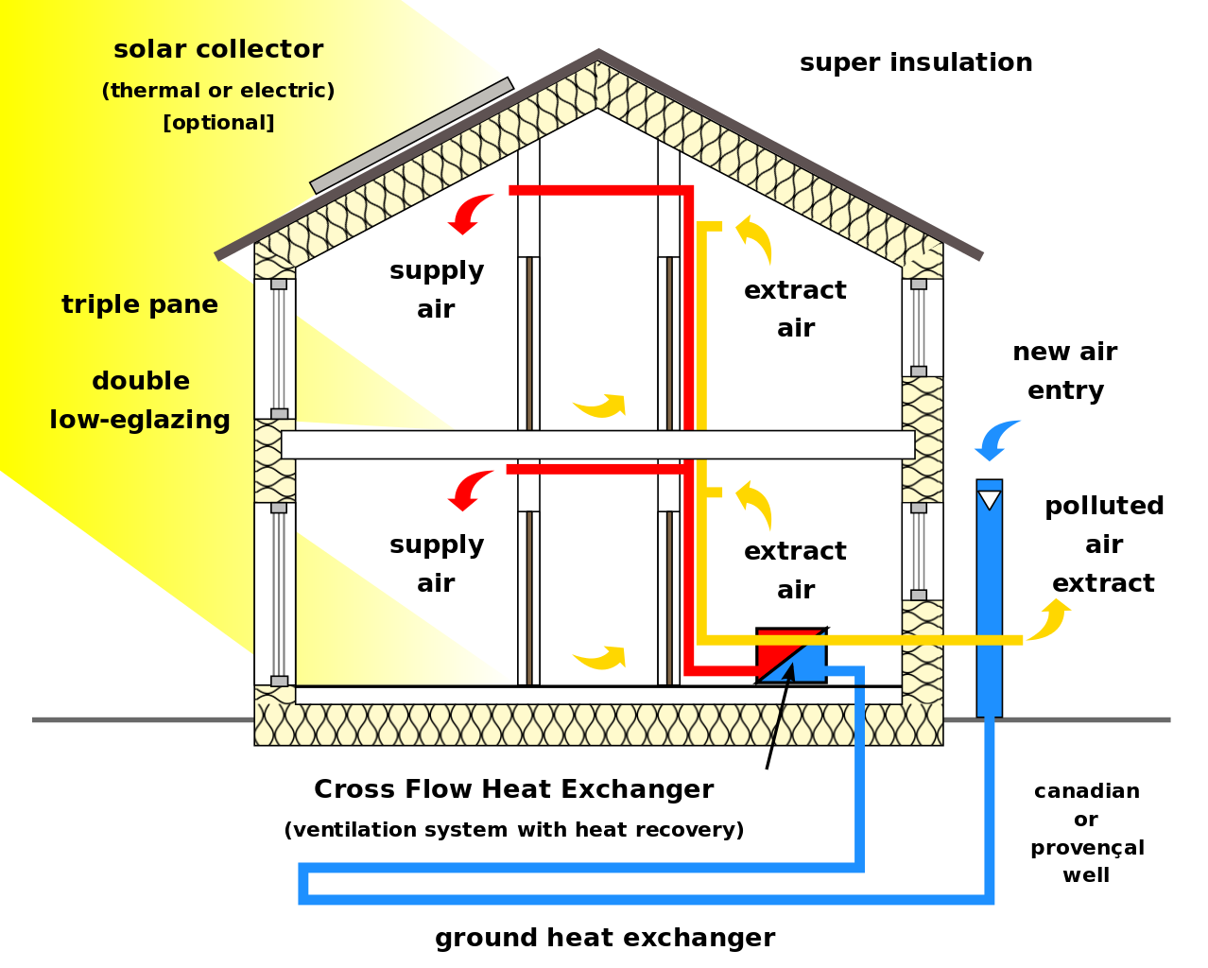

**BRICK HOUSES**



Insulation Double glazing Curtains Carpet

Double brick Awnings Window orientation Verandas

Metal or light tile roofing Air vents High ceilings Trees for shading

**OCEAN CURRENTS**

Warm and cold currents moderate the climate.

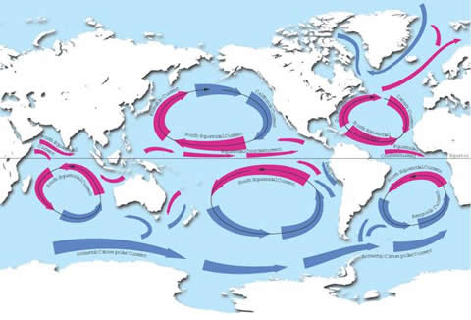

**LAND AND SEA BREEZES**

**During the day the sea is cooler than the land. Air above the land expands becomes less dense and rises and is replaced by the denser cool sea breeze (A). During the night the land cools quickly and the air above the sea expands and rises and is replaced by the denser cool land breeze. (B)**

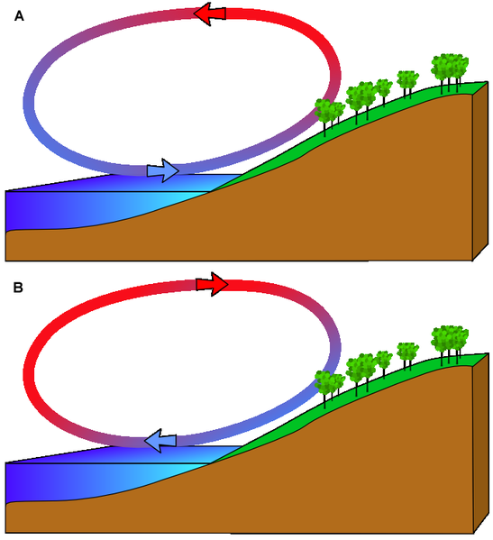

**THUNDERSTORMS**

During the day the sun heats the land and the air above the land becomes hot, expands and rises in a convection current. If the current becomes strong the current rises to great heights as it cools. Moisture in the air in the current condenses and forms rain and sometimes hail.



